**Anudip Foundation**

A

PROJECT REPORT ON

**“Expense Manager System”**

SUBMITTED BY

**Student Id: AF04956938**

**Student Name: Patel Parth**

UNDER GUIDENCE

**MISS.RAJSHRI C. THETE**

# ACKNOWLEDGMENT

I would like to thank the people who helped me in completion of this project and with deep content and pleasure I express my gratitude toward those people who have given me their precious time and guidance in developing project. It’s my privilege to express my sincere thanks and demo sense of gratitude to my guide Miss.Rajshri Thete for imparting me valuable guidance during the preparation of these papers. She helped me by suggesting me many references of emerge out with a perfect presentation.

Thanking You.

Sincerely

Patel Parth

## Index

|  |  |  |
| --- | --- | --- |
| Sr.No | Particular | Page No |
| 1 | Introduction | 4 |
| 2 | Objective | 5 |
| 3 | Proposed System | 6 |
| 4 | Feasibility Study | 7 |
| 5 | Hardware & Software Requirements | 8 |
| 6 | System Design | 9 |
| 7 | Database | 10 |
| 8 | I/O Screens | 14 |
| 9 | Benefits | 20 |
| 10 | Future Enhancement | 20 |
| 11 | Conclusion | 21 |
| 12 | Bibliography | 22 |

### 

### INTRODUCTION

The Expense Manager System is a web-based financial tracking and budgeting application that allows users to efficiently manage their income, expenses, and categories. This system provides users with the ability to create accounts, define categories, and record both income and expenses. The solution ensures better financial planning and monitoring while also offering user authentication and secure data storage.

### OBJECTIVES

* Provide users with a simple interface to manage daily income and expenses.
* Organize transactions under categories for detailed analysis
* Ensure data security and profile-based access.
* Generate accurate and reliable records for financial insights.
* Support future scalability and enhancements such as reporting and visualization.

**PROPOSED SYSTEM**

The Expense Manager System is designed to:  
- Allow users to register and maintain profiles.   
- Enable categorization of income and expenses under custom-defined categories.  
- Record transactions with attributes such as name, icon, date, amount, and type.  
- Maintain audit details such as creation and update timestamps.  
- Provide flexibility to manage both income and expenses under a unified profile.

### FEASIBILITY STUDY

1. **Technical Feasibility**: The system can be developed using existing technologies such as Java, Spring Boot, ReactJS, and MySQL.
2. **Economical Feasibility**: The development cost is minimal compared to the value of having a personal finance tracking system.
3. **Operational Feasibility**: The system is user-friendly and requires minimal training

**HARDWARE AND SOFTWARE REQUIREMENTS**

* **HARDWARE :-** 
  + Operating System: Windows10 and Linux
  + CPU: Pentium III (700MHz) and above
  + Memory: 128 MB and above
  + Capacity: 4GB of hard drive
  + Processor: Intel i3 or above
* **SOFTWARE :-** 
  + Backend: Java (Spring Boot)
  + Frontend: ReactJS
  + MS Word
  + Web Browser: Microsoft Internet Explorer, Mozilla, Google Chrome or later **o** My SQL Server (back-end) **o** Operating System: Window XP / Windows7 / Windows

### SYSTEM DESIGN

1. **ER** **Diagram**

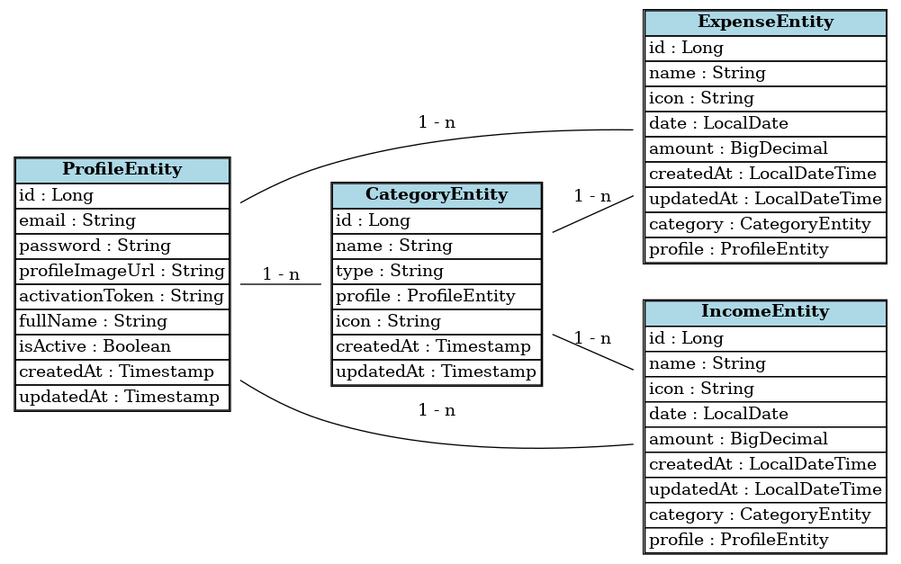

**Database:**

**Profile Table**

|  |  |  |  |
| --- | --- | --- | --- |
| **SR.NO** | **ATTRIBUTES** | **TYPE** | **KEY** |
| 1 | **Id** | **Long** | Primarykey |
| **2** | **Password** | **String** |  |
| **3** | **profileImageUrl** | **String** |  |
| **4** | **activationToken** | **String** |  |
| **5** | **fullName** | **String** |  |
| **6** | **isActive** | **bool** |  |
| **7** | **createdAt** | **Timestemp** |  |
| **8** | **updatedAt** | **Timestemp** |  |

**Category Table**

|  |  |  |  |
| --- | --- | --- | --- |
| **SR.NO** | **ATTRIBUTES** | **TYPE** | **KEY** |
| 1 | **Id** | **Long** | **Primary key** |
| **2** | **Name** | **String** |  |
| **3** | **Type** | **String** |  |
| **5** | **icon** | **String** |  |
| **6** | **Profile_id** | **Long** | **Foreign Key** |
| **7** | **CreatedAt** | **Timestemp** |  |
| **8** | **UpdatedAt** | **Timestemp** |  |

**Expense Table**

|  |  |  |  |
| --- | --- | --- | --- |
| **SR.NO** | **ATTRIBUTES** | **TYPE** | **KEY** |
| 1 | **Id** | **Long** | **Primary key** |
| **2** | **Name** | **String** |  |
| **3** | **Icon** | **String** |  |
| **4** | **Date** | **LocalDate** |  |
| **5** | **Amount** | **BigDecimal** |  |
| **7** | **createdAt** | **Timestemp** |  |
| **8** | **updatedAt** | **Timestemp** |  |
| **9** | **category_id** | **Long** | **Foreign Key** |
| **10** | **profile_id** | **Long** | **Foreign Key** |

**Income Table**

|  |  |  |  |
| --- | --- | --- | --- |
| **SR.NO** | **ATTRIBUTES** | **TYPE** | **KEY** |
| 1 | **Id** | **Long** | **Primary key** |
| **2** | **Name** | **String** |  |
| **3** | **Icon** | **String** |  |
| **4** | **Date** | **LocalDate** |  |
| **5** | **Amount** | **BigDecimal** |  |
| **7** | **createdAt** | **Timestemp** |  |
| **8** | **updatedAt** | **Timestemp** |  |
| **9** | **category_id** | **Long** | **Foreign Key** |
| **10** | **profile_id** | **Long** | **Foreign Key** |

**SAMPLE I/O SCREEN**

**Login**

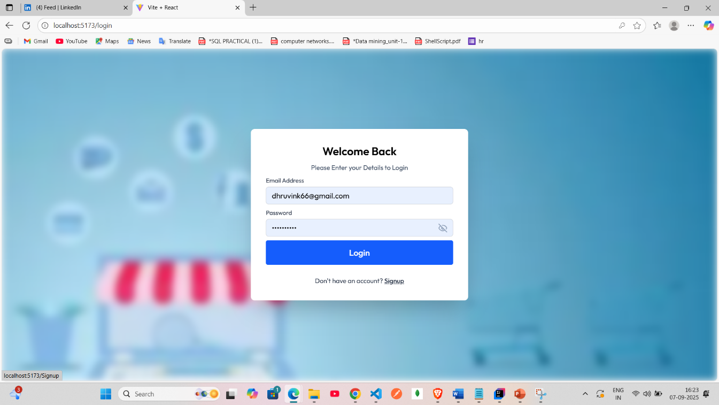

**SignUP**

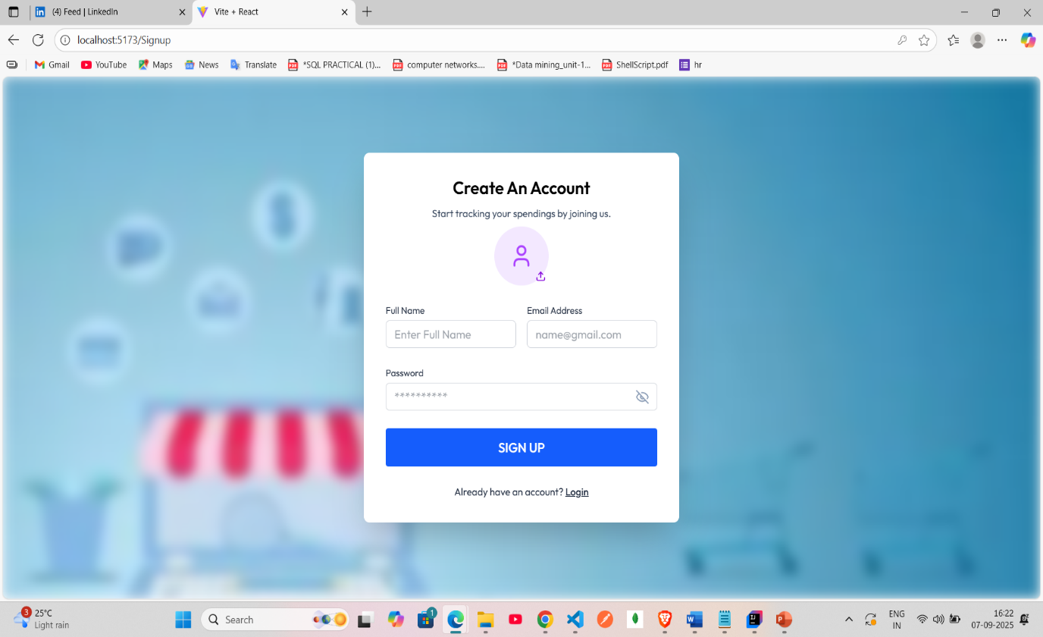

**DashBoard**

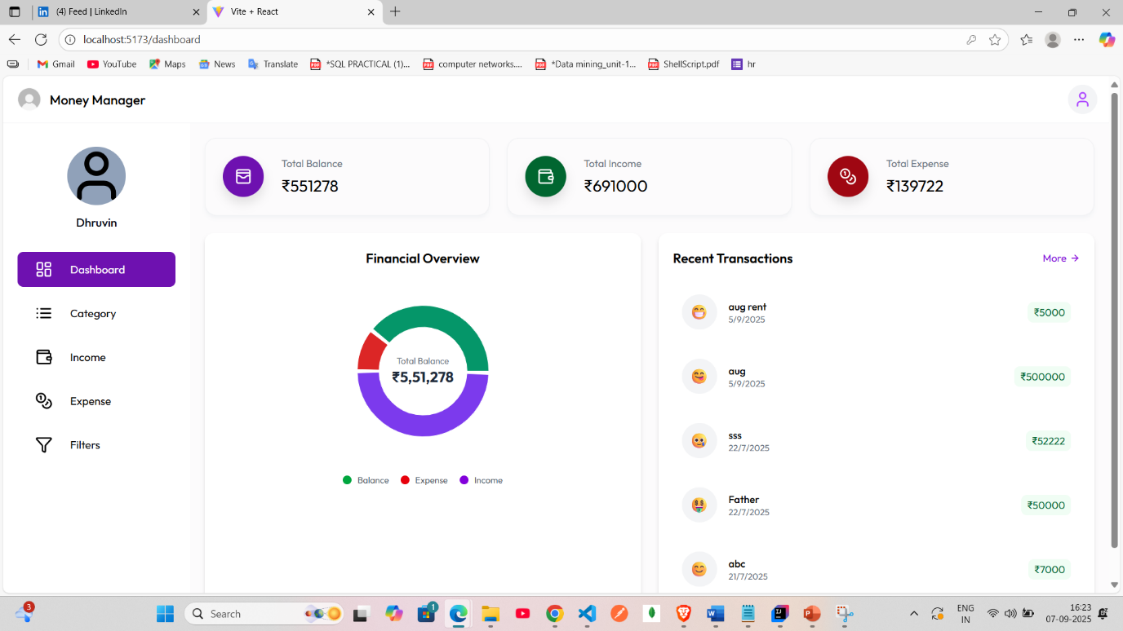

**Category**

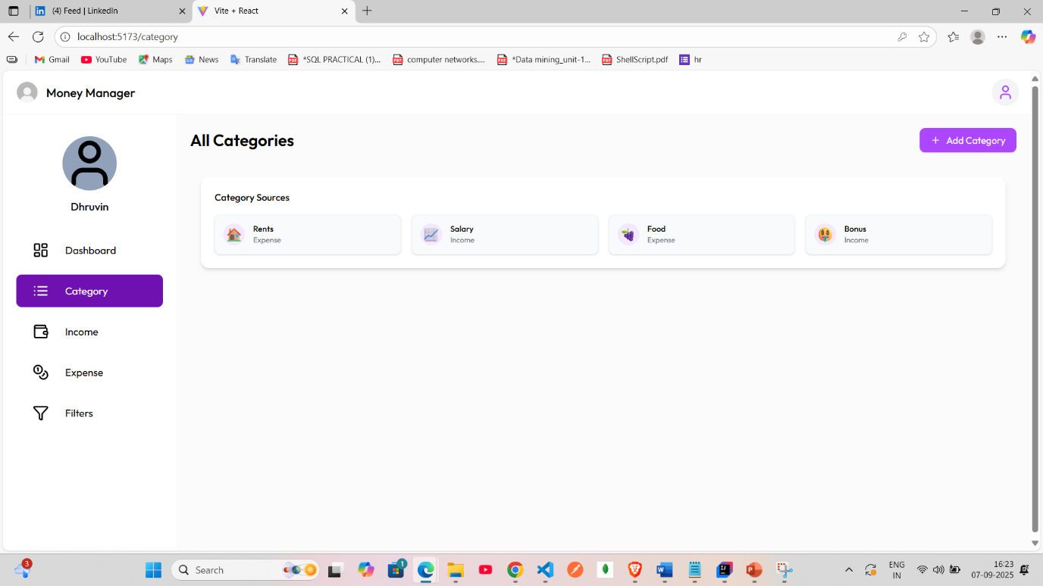

**Add Category**

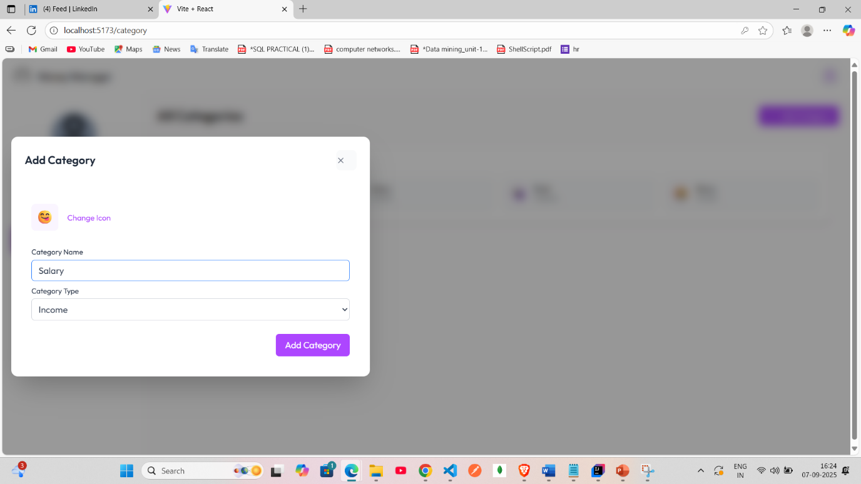

**Income**

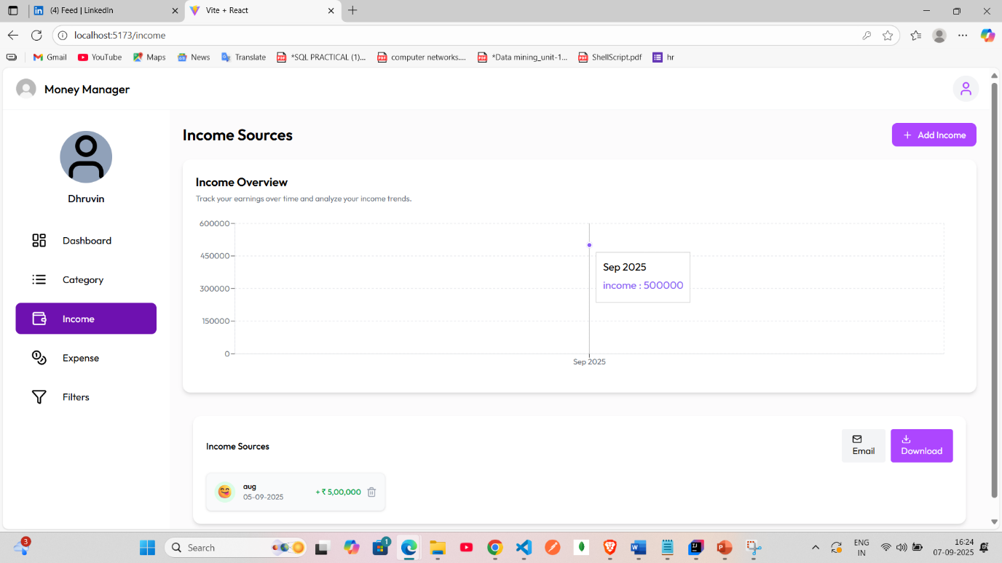

**Add Income**

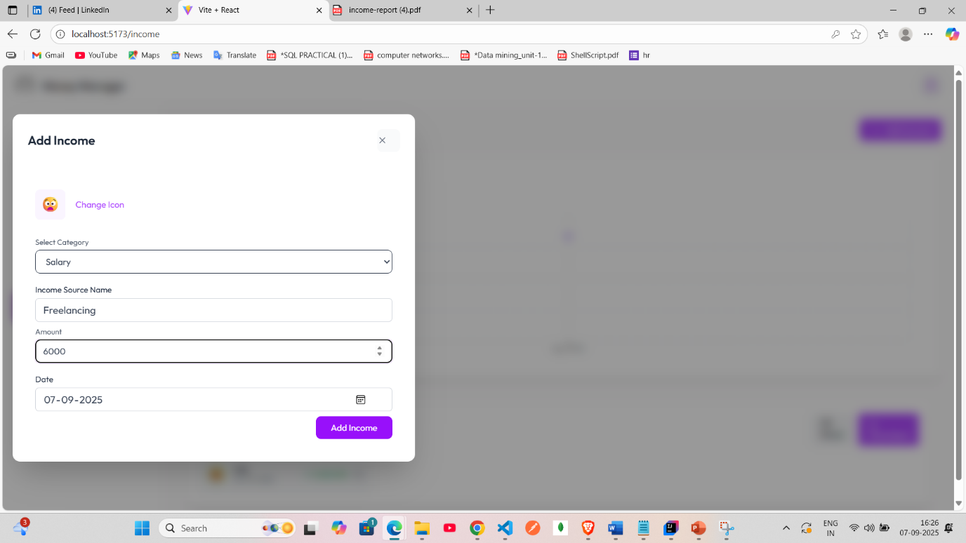

**Income Report**

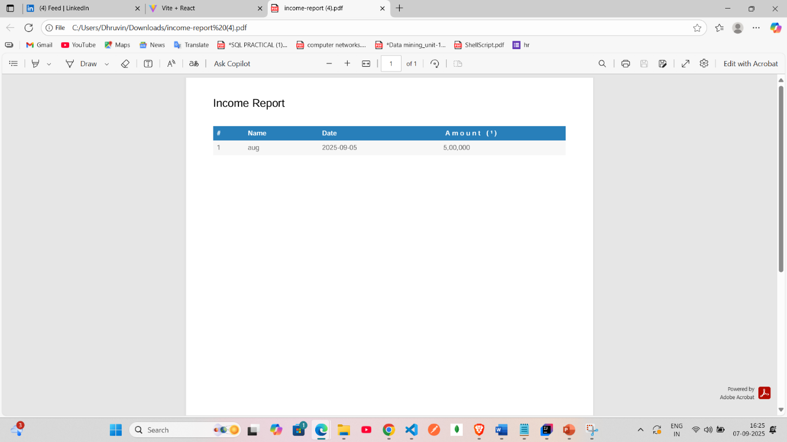

**Expense**

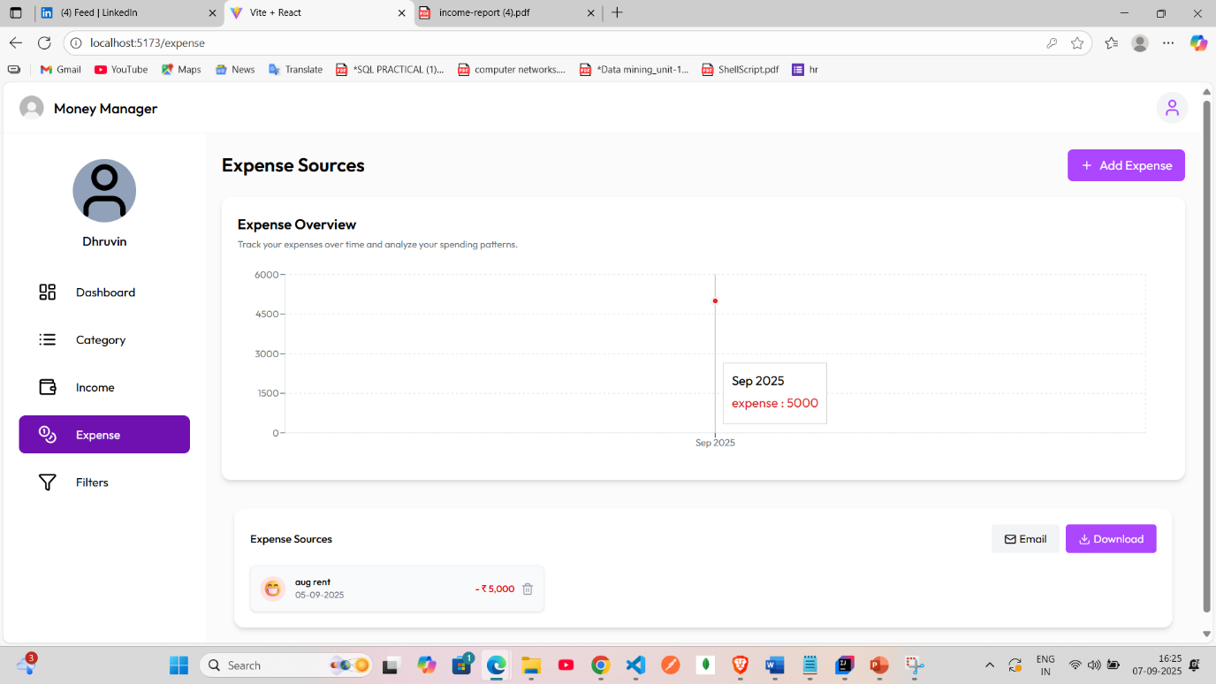

**Add Expense**

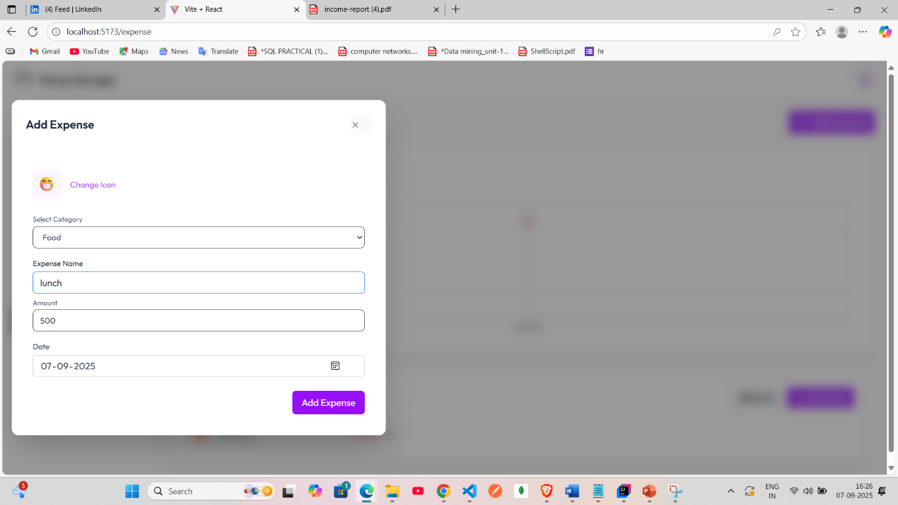

**Filter Transaction**

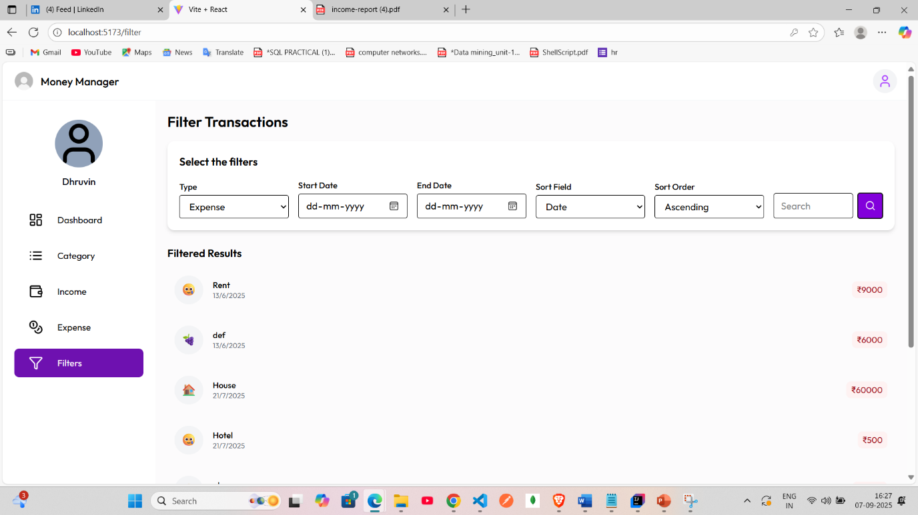

### BENEFITS OF SYSTEM

- Simplifies financial management for users.  
- Provides detailed categorization of income and expenses.  
- Ensures security and user-specific data storage.  
- Reduces errors in manual record keeping.  
- Lays a foundation for advanced features like analytics and reports.

**FUTURE ENHANCEMENT**

- Generate detailed reports and charts for financial analysis.

- Enable budget setting and alert notifications.

- Provide AI-based spending suggestions.

- Add mobile application support.

- Multi-currency support with conversion rates.



### CONCLUSION

The Expense Manager System provides an efficient solution for personal financial management by combining ease of use, strong data management, and security. The system supports structured categorization of income and expenses, ensuring users can maintain better control over their financial activities. Future enhancements will further strengthen its capabilities, making it an essential tool for financial planning.

### BIBLIOGRAPHY

* D. Hoyle, ISO 9000 Quality Systems Handbook 4th ed., ButterworthHeinmann, 2001,
* [http://xandaro.com/ .](http://xandaro.com/)
* www.w3school.com